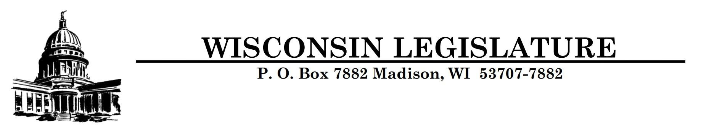

**FOR IMMEDIATE RELEASE CONTACT:**

**October 3, 2024 Rep. David Steffen (608) 237-9104**

**Rep. Joel Kitchens (608) 267-9101**

**Rep. Jerry O’Connor (608) 237-9152**

**Sen. Rachael Cabral-Guevara (608) 266-0718**

**Legislators Announce “Tax-Free Retirement” Legislation**

*Proposal delivers financial relief to Wisconsin’s seniors*

**Madison, WI** — On Wednesday, State Representatives David Steffen (R-Howard), Joel Kitchens (R-Sturgeon Bay), Jerry O’Connor (R-Fond du Lac), and State Senator Rachael Cabral-Guevara (R-Fox Crossing) announced plans to introduce a “Tax-Free Retirement” proposal during the upcoming 2025-26 legislative session. The 2025 proposal will closely mirror [2023 Assembly Bill 1021,](https://docs.legis.wisconsin.gov/2023/proposals/reg/asm/bill/ab1021) which passed the Legislature with bipartisan support at the end of last session. New provisions have been included to broaden legislative support and provide a pathway for Governor Evers to sign the proposal into law next year.

“Tax-Free Retirement is something that Wisconsinites across the state want, which is why I am proud to be re-introducing this proposal. Historic inflation has been particularly hard on our fixed-income retirees and we should be focused on finding ways to make Wisconsin an affordable place to retire,” said Rep. Steffen.

The proposed legislation exempts $75,000 of retirement income for single filers and $125,000 for married joint filers from being subject to state income tax. If enacted, Wisconsin would join 13 other states in exempting retirement income from taxation.

“We can’t do much about the weather, but we can lower the tax burden on seniors. Two of our neighboring states, Illinois and Iowa, already have a form of tax-free retirement,” Rep. Kitchens said, “We can’t afford to keep losing seniors to other states. When they leave, we don’t just lose revenue. Families miss out on sharing important life events. Wisconsin is sitting on a $3 billion surplus, we can afford this tax cut more than we can afford not doing it.”

“Once again, we must make retiring in Wisconsin more affordable,” Rep. O’Connor said, “On one hand, we must help retirees already in Wisconsin, on the other hand, we must make sure they stay here.”

“Our retired parents and grandparents deserve to keep the money they’ve put away throughout their career,” said Sen. Cabral-Guevara. “Punishing them for staying near their family in Wisconsin once they retire isn’t the way to treat our seniors. As I’ve repeatedly said in the past, I trust Wisconsinites to spend their money more wisely than the government.”

Although this popular proposal was passed by the Legislature this session, it was vetoed by Governor Evers. The adjusted version to be introduced next session incorporates modest changes aimed at gaining the Governor’s support. The savings provided to retirees under this proposal will be in addition to any retirement income that is already tax-exempt in Wisconsin, such as Social Security.

For more information please contact the offices of State Representative David Steffen at

Rep.Steffen@legis.wisconsin.gov or (608)237-9104, State Representative Joel Kitchens at Rep.Kitchens@legis.wisconsin.gov or (608)237-9101, State Representative Jerry O’Connor at [Rep.O’Connor@legis.wisconsin.gov](mailto:Rep.O’Connor@legis.wisconsin.gov) or (608) 237-9152, or State Senator Rachael Cabral-Guevara at Sen.Cabral-Guevara@legis.wisconsin.gov or (608)-266-0718.