**Re-Elect Jerry O’Connor for the *new* State Assembly 60th  District Seat**

***Contact: Committee to Elect Jerry O’Connor | P.O. Box 651 Fond du lac, Wi 54936***

[***website www.jerryoconnor4wi-assemby.com | joc@jerryoconnor4wi-assembly.com***](http://website%20www.jerryoconnor4wi-assemby.com%20%20%20|%20%20%20joc@jerryoconnor4wi-assembly.com)



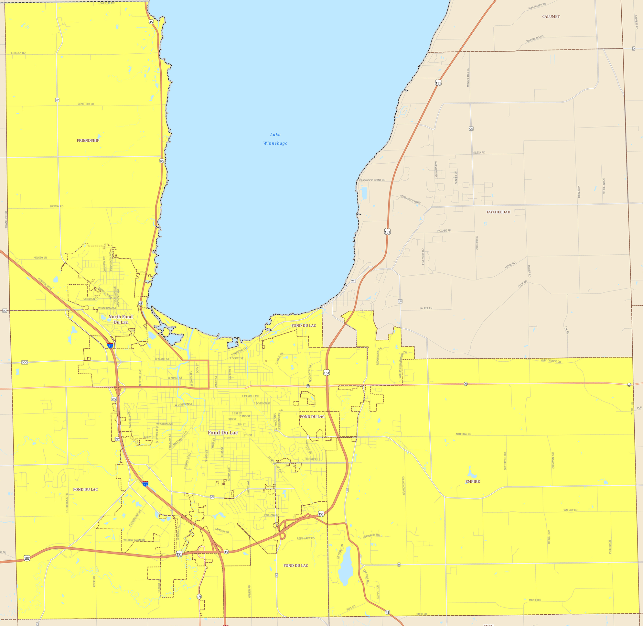

**North Fond Du Lac**

**Fond Du Lac** Township

**Friendship Township**

Township

**Fond Du Lac**

**Township**

Township

**Empire**

**Township**

Township

**The 60th District include the following political subdivisions:**

**The City of Fond du Lac, the Village of North Fond du lac, and**

**the townships of Fond du lac, Empire and Friendship**